**INITIAL OBSERVATIONS YEAR**

Some remarks:

-I have focused on getting more histograms instead of heat maps.

-I have also attached the images, which are available on the shared folder as well (>FaF/Stats/Year Plots).

## ###PACKAGES USED##

install.packages("tidyverse")

install.packages("ggplot2")

install.packages("esquisse")

install.packages("shiny")

library("esquisse")

library("tidyverse")

library("ggplot2")

library("shiny")

# GENITIVE PL

The initial observation of how many total occurrences to total forms gives predictable results.

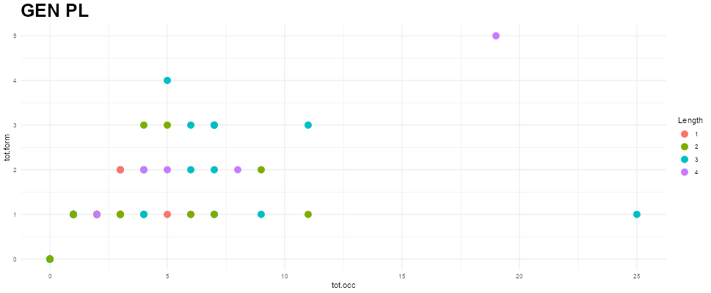

### #CODE

ggplot(YrGenPlu.wide) +

aes(x = tot.occ, y = tot.form, colour = Length) +

geom_point(shape = "circle", size = 4L) +

scale_color_hue(direction = 1) +

labs(title = "GEN PL") +

theme_minimal() +

theme(plot.title = element_text(size = 25L, face = "bold"))

Concerning the specific characteristics of the participants these are the results of my analyses:

## ·Age – form variation:

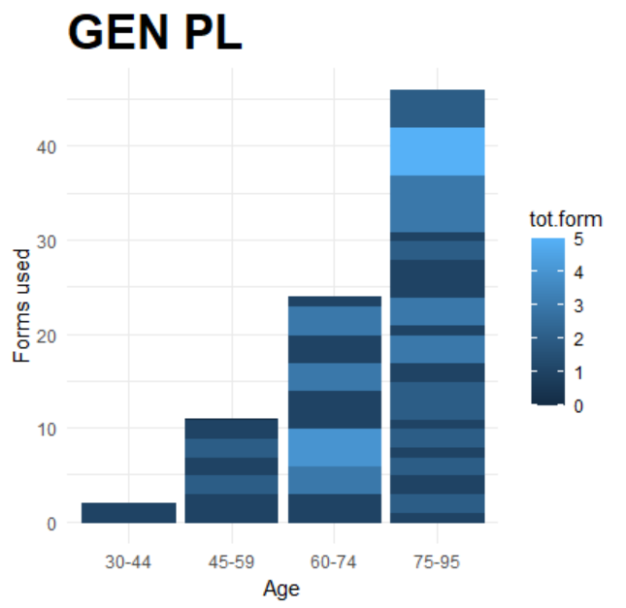

There are not that many data, but I guess there would be a tendency for older speakers to use more forms, according to this.

### #CODE

ggplot(YrGenPlu.wide) +

aes(

x = `Age group`,

y = tot.form,

fill = tot.form,

colour = tot.form

) +

geom_col() +

scale_fill_gradient() +

scale_color_gradient() +

labs(x = "Age", y = "Forms used", subtitle = "GEN PL") +

theme_minimal() +

theme(

plot.subtitle = element_text(size = 25L,

face = "bold")

)

## ·Gender/form variation

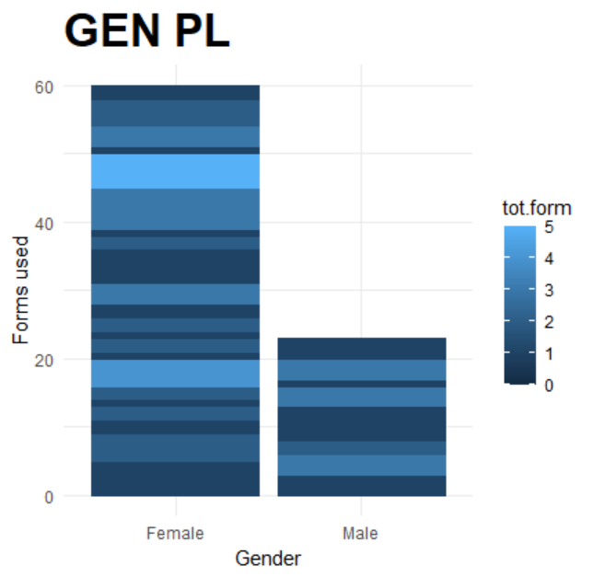

So far, given that we have more women participants than me, it is not possible to make any meaningful observations.

### #CODE

ggplot(YrGenPlu.wide) +

aes(

x = `Gender`,

y = tot.form,

fill = tot.form,

colour = tot.form

) +

geom_col() +

scale_fill_gradient() +

scale_color_gradient() +

labs(x = "Gender", y = "Forms used", subtitle = "GEN PL") +

theme_minimal() +

theme(

plot.subtitle = element_text(size = 25L,

face = "bold")

)

## Village + variation

In theory, here some villages would be more prone to variation than others, but I am afraid forms are not being counted right….

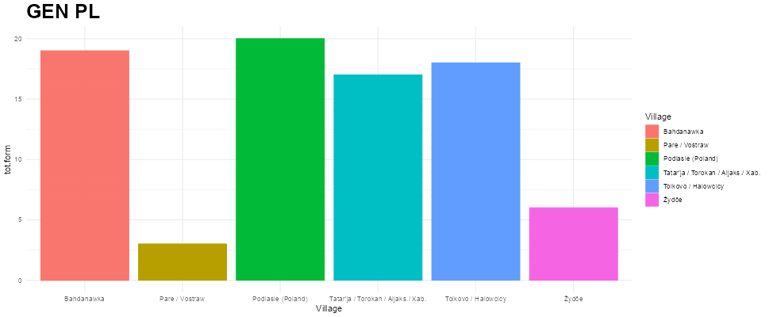

### #CODE

ggplot(YrGenPlu.wide) +

aes(

x = Village,

y = tot.form,

fill = Village,

colour = Village

) +

geom_col() +

scale_fill_hue(direction = 1) +

scale_color_hue(direction = 1) +

labs(subtitle = "GEN PL") +

theme_minimal() +

theme(

plot.subtitle = element_text(size = 25L,

face = "bold")

)